Reaction Mechanisms and Reaction Profiles Practice
1. A. How many elementary steps are in the reaction mechanism shown below?
B. On the energy profile below, indicate
a. the position of the reactants and products
b. the activation energy for the overall reaction
c. ΔE for the reaction
d. the point on the plot that represents the energy of the intermediate
e. the transition state (activated complex)
f. the rate-determing step
g. how a catalyst would affect the reaction
C. Is the overall reaction endothermic or exothermic?
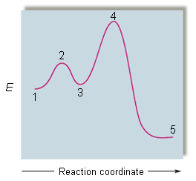
2. Consider the following 3-step mechanism for an exothermic reaction.
Step 1: Cl₂(g) ↔ 2Cl(g) fast, k₁ forward, k₋₁ reverse
Step 2: Cl(g) + CHCl₃(g) → HCl(g) + CCl₃(g) slow, k₂
Step 3: Cl(g) + CCl₃(g) → CCl₄(g) fast, k₃
A. What is the overall reaction?

B. What are the reaction intermediates?
C. Write the rate law that is consistent with this mechanism, showing how you
derive it.

3. A. How many elementary steps are in the reaction mechanism shown below?
B. On the energy profile below, indicate
a. the position of the reactants and products
b. the activation energy for the overall reaction
c. ΔE for the reaction
d. the point on the plot that represents the energy of the intermediate
e. the transition state (activated complex)
f. the rate-determing step
g. how a catalyst would affect the reaction
C. Is the overall reaction endothermic or exothermic?
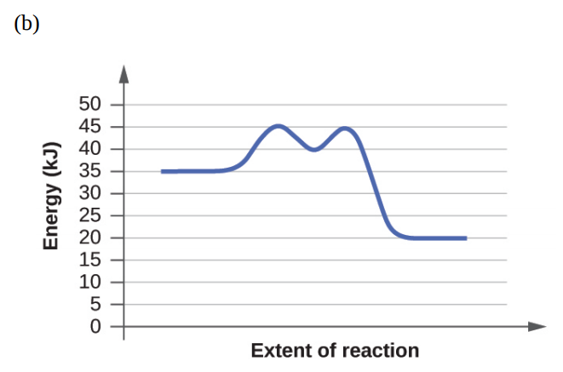
4. A. How many elementary steps are in the reaction mechanism shown below?
B. On the energy profile below, indicate
a. the position of the reactants and products
b. the activation energy for the overall reaction
c. ΔE for the reaction
d. the point on the plot that represents the energy of the intermediate
e. the transition state (activated complex)
f. the rate-determing step
g. how a catalyst would affect the reaction
C. Is the overall reaction endothermic or exothermic?

5. Consider the following 3-step mechanism for an exothermic reaction.
Step 1: I₂(g) ↔ 2I(g) fast, k₁ forward, k₋₁ reverse
Step 2: l(g) + H₂(g) ↔ H₂I(g) fast, k₂ forward, k₋₂ reverse
Step 3: H₂I(g) + I(g) → 2HI(g) slow, k₃
A. What is the overall reaction?

B. What are the reaction intermediates?
C. Write the rate law that is consistent with this mechanism, showing how you
derive it.

6. A. How many elementary steps are in the reaction mechanism shown below?
B. On the energy profile below, indicate
a. the position of the reactants and products
b. the activation energy for the overall reaction
c. ΔE for the reaction
d. the point on the plot that represents the energy of the intermediate
e. the transition state (activated complex)
f. the rate-determing step
g. how a catalyst would affect the reaction
C. Is the overall reaction endothermic or exothermic?
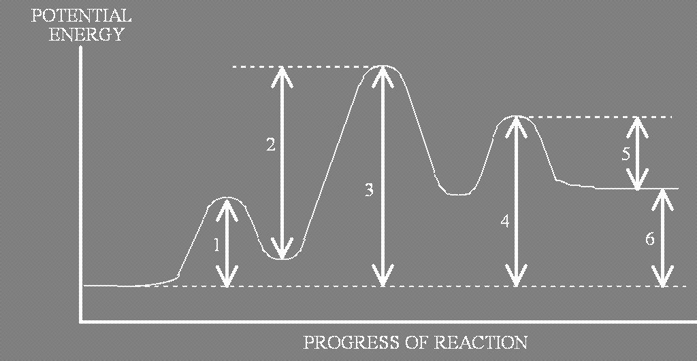
7. The activation energy for the reaction
NO₂(g) + CO(g) NO(g) + CO₂(g)
is 125 kJ/mole, and ΔE for the reaction is -216 kJ/mole. What is the activation
energy for the reverse reaction [NO(g) + CO₂(g) NO₂(g) + CO(g)]?

8. For a certain reaction, the activation energy is greater for the forward reaction than the reverse reaction. Does the reaction have a positive or negative value for ΔE?

9. The following mechanism has been proposed for the reaction of methane gas with chlorine gas. All species are in the gas phase.

Step 1: Cl₂ ↔ 2Cl fast equilibrium
Step 2: CH₄ + Cl → CH₃ + HCl slow
Step 3: CH₃ + Cl₂ → CH₃Cl + Cl fast
Step 4: CH₃Cl + Cl → CH₂Cl₂ + H fast
Step 5: H + Cl → HCl fast

A. In the mechanism, is CH₃Cl a catalyst, or is it an intermediate? Justify your answer.

B. Identify the order of the reaction with respect to each of the following according to the mechanism. In each case, justify your answer.
(i) CH₄

(ii) Cl₂

10. The rate law for a reaction is found to be Rate = k[A]²[B]. Which of the following mechanism gives this rate law?

- A + B ↔ E (fast) II. A + A E (fast)
E + B C + D (slow) E + B C + D (slow)

III. A + B ↔ E (fast)
E + A C (slow)

11. The following mechanism has been proposed for the decomposition of ozone into oxygen gas. All species are in the gas phase.

O₃ ↔ O₂ fast, reversible (k₁ forward, k₋₁ reverse)
O₃ + O₂ → 2O₂ slow (k₂)

A. What is the overall reaction?

B. What are the reaction intermediates?
C. Write the rate law that is consistent with this mechanism, showing how you
derive it.

