First Semester Final Exam Review – 2020
This review is to give you an idea of some areas you may need to study and to give you a little practice with the concepts. It is NOT a complete list. If you discover sections that you've struggled with during the school year, you should return to your NOTES and ALL HOMEWORK and CLASSWORK HANDOUTS for that topic.

Bring pencils and a scientific calculator with you to the exam. NO sharing of calculators will be permitted. You will be able to use: 1) periodic table, 2) polyatomic ion sheet, 3) periodic trends handout, and 4) your composition book

Introduction to Chemistry
Vocabulary Words and/or Topics: mass, matter, qualitative data, quantitative data,

- Define matter any substance with mass and volume
- Contrast mass and weight. Mass is the amount of matter. Weight is a force due to gravity. SO . . . if an astronaut travels to the moon, they will have the SAME MASS but less WEIGHT (due to lower gravity)

Data Analysis
Vocabulary Words and/or Topics:
Accuracy, precision, conversion factor, density, dimensional or unit analysis, graph, scientific notation, significant figures

- Write the following numbers in scientific notation and indicate the number of significant figures in each.

Convert to scientific notation  ↓ |  | # of Significant Figures?  ↓
7.51 x 10² m | 751 meters | 3
7.81 x 10⁵ m | 781000 meters | 3
7.810000 x 10⁵ m | 781000.0 meters | 7
5.0 x 10⁻³ g | 0.0050 grams | 2
7.45 x 10⁻⁶ g | 0.00000745 grams | 3
3 x 10⁰ K | 3 Kelvin | 1
3.0 x 10⁹ atoms | 3.0 billion atoms | 2

2. Perform the following operations and report the answer to the proper number of significant figures with the proper units
    - 10.2 m x 178.9 m = 1820 m²
    - 10.1 cm + 0.672 cm = 10.8 cm
    - 5.70 cm x 6.40 cm x 7.320 cm = 267 cm³
    - 5.73 g / 7.64 cm³ = 0.750 g/cm³
    - 0.01472 kg + 735.0 kg = 735.0 kg (the 0.01472 added is “insignificant” when you round to sig figs)

3. Convert each of the following quantities and answer with the correct number of significant figures and units.
    - 0.143 hours to seconds 515 seconds
    - 1.098 km to m 1098 m
    - 1.70 mL to L 0.00170 L
    - 5.7 mm to cm 0.57 cm
    - 0.924 kg to grams 924 g
    - 16 ft³ to in³ 28000 in³
    - 35.72 mL to cm³ 35.72 cm³

4. What is the density of a substance that has a volume of 3.07 cm³ and a mass of 8.76 g? 2.85 g/cm³

5. Calcium chloride is used as a de-icer on roads in winter. It has a density of 2.50 g/cm³. What is the volume of 7.91 g of this substance? 3.16 cm³

Matter: Properties and Changes Vocabulary Words and/or Topics: allotropes, atom, chemical change, chemical properties, compounds, element, extensive properties, gas, heterogeneous mixture, homogeneous mixture, intensive properties, law of conservation of mass, liquid, mixture, periodic table, physical change, physical properties, solid, solution, states of matter, substance, vapor

- Classify the following materials as heterogeneous mixtures (HE), solutions (HO), compounds (C), or elements (E):
A. air HO
  - paper HE
  - table salt C
  - granite HE
  - whole milk HE
  - plutonium E
  - distilled water C

- How many phases are present in a glass of soda on ice? Three. Solid ice. Liquid water. Gas bubbles

- Classify the following properties as intensive or extensive:
  - mass extensive; mass is different depending on how much
  - color intensive; a small amount or large amount will be the same color
  - ductility intensive
  - length extensive
  - melting point intensive

- Classify the following as chemical or physical properties:
color P | stability C | stiffness P | reactivity C
flammability C | ductility P | melting point P | reacts with air C
solubility P | electrical conductivity P | corrosive C | blue P
- Differentiate between homogenous mixtures dissolved and evenly mixed; uniform composition; Gatorade and heterogeneous mixtures NOT dissolved; not mixed on a particle level; cookies. Give examples of each.
- What are chemical properties? Properties that can only be observed by attempting a chemical reaction
- Why is a change of phase considered to be a physical change? A change in state of matter doesn’t change the chemical. For example, ice is H₂O and liquid water is still H₂O
- What is a compound? chemical combination of 2 or more different elements; the compound has a DEFINITE composition
- What is the difference between qualitative and quantitative data? qualitative is description; quantitative is numbers/measurements
- What is an alloy? Is it a homogeneous mixture, heterogeneous mixture, or a compound? Give an example. An alloy is a homogeneous mixture of 2 or more different types of metal. Brass is a mixture of copper and zinc.
- Which of the following are a pair of isotopes? Why?
  - ¹⁴N and ¹⁴O NO
  - ³⁵Cl and ³⁴Cl YES; because they are the same element
  - Si that has 12 neutrons and sulfur that has 12 neutrons NO
  - two bromine atoms with 54 neutrons each YES; because they are the same element . . . even though they have the same mass number, they can be called “isotopes” when comparing do other bromine isotopes
4
2
0
-1

Development of the Modern Periodic Table and the Elements
Vocabulary Words and/or Topics: actinides, alkali metals, alkaline earth metals, groups, halogen, transition metal, ion, ionization energy, metal, metalloid, noble gas, nonmetal, octet rule, period, periodic law
- How do chemists use the periodic law to classify elements? Elements are classified and organized based on those chemical and physical properties. They are placed in groups according to valence electrons
- What is the name of a vertical column on the periodic table? group A horizontal row? period
- Why is beryllium in group 2? properties of Alkaline earth metals What do all atoms in Group 2 have in common? 2 valence electrons
- Who developed the modern periodic table? How was it later modified? Mendeleev designed the 1st periodic table in order of increasing atomic mass and grouped elements based on similar physical and chemical properties. Moseley improved on the organization by placing them in increasing atomic number

- Sketch a simplified version of the periodic table and indicate the location of groups, periods, metals, nonmetals, and metalloids. group = column period = row

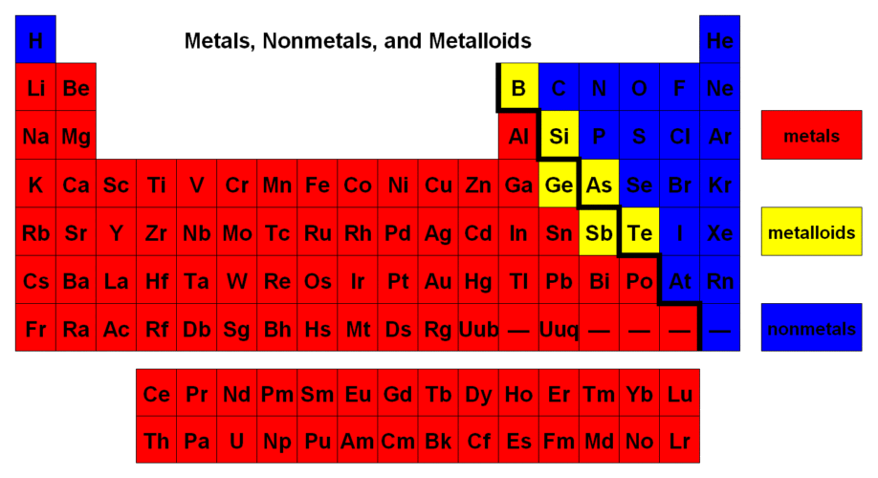

- How does the shielding effect affect atomic size? Greater shielding effect generally “pushes” electrons further from the nucleus and increases atomic radius

- Which has a larger radius?
  - Mg or Si (Si has more protons than Mg which “pull” electrons closer to the nucleus)
  - Ti or Cr (Cr has more protons than Ti which “pull” electrons closer to the nucleus)
  - Li or Cs (Cs has more energy levels and greater shielding effect than Li)
  - Ni or Zn (Zn has more protons than Ni which “pull” electrons closer to the nucleus)
- Which has the higher ionization energy?
  - Ba or Bi (Bi has more protons than Ba which “pull” electrons closer to the nucleus and requires MORE energy to remove one electron)
  - Al or Ti (Ti has more energy levels and greater shielding effect than Al, so MORE energy is required to remove an electron from Al which is closer to the nucleus and has less shielding)
  - C or O (O has more protons than C which “pull” electrons closer to the nucleus and requires MORE energy to remove one electron)
  - Br or Kr (Kr has more protons than Br which “pull” electrons closer to the nucleus and requires MORE energy to remove one electron)
  - P or O (P has more energy levels and greater shielding effect than O, so MORE energy is required to remove an electron from O which is closer to the nucleus and has less shielding)
- Which has the larger electronegativity?
  - B or F (F has more protons than B which “pull” electrons to the nucleus with GREATER electronegativity)
  - Cl or S (Cl has more protons than S which “pull” electrons to the nucleus with GREATER electronegativity)

- For the element aluminum, the number 26.98 represents atomic mass (or average atomic mass)

Atomic Structure
Vocabulary Words and/or Topics: proton, neutron, electron, atomic number, mass number, quantum numbers, orbital, sublevel, energy level, group, period

- Describe what each of these scientists discovered about the atom. What was the name of each of their theories?
  - Dalton billiard ball (solid, indestructible spheres)
  - Thomson plum pudding (electrons randomly suspended in a positively-charged “gel/pudding”)
  - Rutherford nuclear model (protons located in a small nucleus, surrounded by moving electrons; the atom is mostly empty space)
  - Bohr planetary model or solar system model (improvement on Rutherford; Bohr model describes the location of electrons in “energy levels” based on increasing energy/distance from the nucleus)
- What are the symbols for the 4 orbital shapes? s, p, d, f
How many sublevels are in the 1st energy level? 1s 2nd? 2s, 2p 3rd? 3s, 3p, 3d 4th? 4s, 4p, 4d, 4f

- What is the symbol for one electron in an orbital diagram? Arrow What is the maximum number of electrons that can occupy the 2s sublevel? 2 The 4f sublevel? 7 The 5d sublevel? 10 The 3p sublevel? 6

- Explain what the energy levels of an atom correspond to on the periodic table. Each period represents electrons entering a new energy level

- Explain how an electron configuration describes an atom. Electron configuration describes the a) energy level with a “big” number, b) the sublevel with a “big number and lowercase letter”, and c) the number of electrons in each sublevel with a superscript number. EXAMPLE: 1s²2s²2p⁴ is oxygen

- Explain what its orbital diagram describes about an atom. Orbital diagram describes the a) energy level with a “big” number, b) the sublevel with a “big number and lowercase letter”, and c) the number of orbitals indicated by the number of boxes, and d) the number of electrons AND the spin of each electron with an arrow.
EXAMPLE: orbital diagram for oxygen is below
↑↓ |  | ↑↓ |  | ↑↓ | ↑ | ↑
1s |  | 2s |  |  | 2p

- If an atom has 14 protons and a mass number of 38, tell the following:
  - number of electrons 14 electrons (atoms has no charge, so the same number of protons/electrons)
  - number of neutrons 24 neutrons
  - atomic number 14 atomic number
- If an atom has an atomic number of 7 and 8 neutrons, tell the following:
  - number of protons 7 protons
  - number of electrons 7 electrons
  - mass number 15 mass number
- Write out the complete electron configuration for the following atoms (NO SHORT CUT)
A. sodium 1s²2s²2p⁶3s¹
  - zinc 1s²2s²2p⁶3s²3p⁶4s²3d¹⁰
  - sulfur 1s²2s²2p⁶3s²3p⁴
  - neon 1s²2s²2p⁶

10. Write the noble gas notation for the electron configuration for the atoms above (9A through 9D)
A. sodium [Ne]3s¹
B. zinc [Ar]4s²3d¹⁰
C. sulfur [Ne]3s²3p⁴
D. neon [He]2s²2p⁶
- Write the noble gas notation for the orbital diagram for each atom above (9A through 9D)
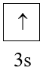
A. sodium [Ne]

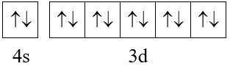
B. zinc [Ar]

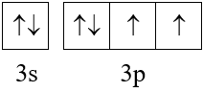
C. sulfur [Ne]

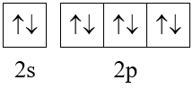
D. neon [He]

- Draw Lewis diagram for ONE ATOM of each of the following (not doing dashes and bonds, yet):
a) sodium 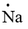, b) carbon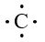, c) fluorine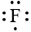 , d) calcium 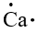, e) phosphorus 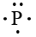

Ionic Compounds
Vocabulary Words and/or Topics: ion, cation, anion, oxidation number, transition metal, roman numerals, polyatomic ions, superscript, subscript, valence electrons, chemical bond, ionic bond
- What type of bond will be formed between:
  - carbon and fluorine polar covalent
  - magnesium and chlorine ionic
  - zinc and copper metallic
  - hydrogen and oxygen polar covalent
- How many valence electrons are in the following atoms: lithium 1, nitrogen 5, aluminum 3, fluorine 7, neon 8, bromine 7, sulfur 6, calcium 2
- Using the octet rule, when the atoms in Problem #2 above turn into ions, what is the charge of each? lithium +1, nitrogen −3, aluminum +3, fluorine −1, neon no ion, bromine −1, sulfur −2, calcium +2

Naming and Formulas for Compounds
- Naming and Formulas for Ionic Compounds
- Naming and Formulas for Covalent Compounds

Write the chemical formula: Write the chemical name:
  - sodium fluoride NaF 8. NaI sodium iodide
  - hydrogen monofluoride HF 9. AlBr₃ aluminum bromide
  - aluminum sulfide Al₂S₃ 10. H₂SO₄ hydrogen sulfate
  - barium sulfide BaS 11. Cl₂O₇ dichlorine heptoxide
  - phosphorus pentachloride PCl₅ 12. HBr hydrogen bromide
  - dinitrogen tetroxide N₂O₄ 13. N₂O₅ dinitrogen pentoxide
  - hydrogen nitrate HNO₃ 14. ICl₃ iodine trichloride

Write the chemical formula: Write the chemical name:
  - sodium sulfite Na₂SO₃ 22. HCl hydrogen monochloride
  - magnesium ion Mg²⁺ 23. Na₂SO₄ sodium sulfate
  - ammonium fluoride NH₄F 24. KNO₃ potassium nitrate
  - oxygen O₂ 25. NH₄⁺ ammonium
  - oxide O²⁻ 26. Mg(OH)₂ magnesium hydroxide
  - hydrogen chlorate HClO₃ 27. H₂CO₃ hydrogen carbonate
  - barium cyanide Ba(CN)₂

Write the chemical formula: Write the chemical name:
  - iron(II) chloride FeCl₂ 33. NiF₂ nickel(II) fluoride
  - iron(III) chloride FeCl₃ 34. F₂ fluorine
  - chromium(III) oxide Cr₂O₃ 35. F⁻ fluoride
  - iron(III) perchlorate Fe(ClO₄)₃ 36. Fe₂S₃ iron(III) sulfide
32. nickel(III) acetate Ni(C₂H₃O₂)₃ 37. CrO chromium(II) oxide
38. Ca₃(PO₄)₂ calcium phosphate

BONDING
- Determining type of bond between 2 elements: ionic, metallic, polar covalent, or nonpolar covalent
- Drawing Lewis diagrams for covalent compounds
- Determine the shape of a covalent molecule and whether the molecule is polar or nonpolar

Type of Bond
Indicate the type of bond formed between the following elements.
1. N and Cl polar covalent 6. K and Br ionic
2. N and N nonpolar covalent 7. Mg and Mg metallic
3. Ca and O ionic 8. Al and Cl ionic
4. C and F polar covalent 9. Si and Cl polar covalent
5. H and O polar covalent 10. Cu and Sn metallic

Lewis Diagrams
For the following compounds: a) draw a Lewis diagram, b) determine the shape of the molecule, and c) determine if the molecule is polar or nonpolar

H₂ linear diatomic nonpolar
O₂ linear diatomic nonpolar
N₂ linear diatomic nonpolar
CCl₄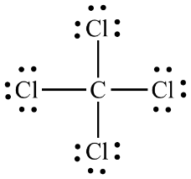 tetrahedral nonpolar
NH₃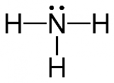 trigonal pyramidal polar
C₂H₆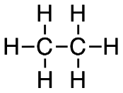 nonpolar (tetrahedral around each C – you don’t need to know that)
SF₂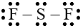 bent polar

CO₂ linear triatomic nonpolar

