Equilibrium Practice

Equilibrium Conceptual | p1 |  | Using Ice: Generic, Then Real But Simple Numbers | p8
Writing the Equilibrium Constant | p3 |  | Solving for K given Initial and at Least one Equilibrium Concentration | p9
Manipulations of K: Reversing or Multiplying | p5 |  | Solving for Equilibrium Concentrations Using Ice, Given K | p10
Solving for K Given All Equilibrium Concentrations | p6 |  | LeChatelier’s Principle, Q, and Responses to Disrupted Equilibria | p12
Solving for an Equilibrium Concentration Given K and Other Equilibrium Concentrations | p7 |  | Answers | p15

Big-Picture Introductory Conceptual Questions

- Which of the following is true for a chemical reaction at equilibrium?
  - only the forward reaction stops
  - only the reverse reaction stops
  - both the forward and reverse reactions stop
  - the rate constants for the forward and reverse reactions are equal
  - the rates of the forward and reverse reactions are equal

- Which of the following is true regarding the concentration of products, for a chemical reaction that is already at equilibrium, assuming no disruptions to the equilibrium?
  - The concentrations of products will not change because there are no more reactants.
  - The concentrations of products will not change because the limiting reagent is gone.
  - The concentrations of products will not change because the forward and reverse rates are equal.
  - The concentrations of products will change continually because of reversibility.

- Which of the following are equal for a chemical system at equilibrium? If all are equal, answer E.
  - the concentrations of reactant and products are equal
  - the rate constants for the forward and reverse reactions are equal
  - the time that a particular atom or molecule spends as a reactant and product are equal
  - the rate of the forward and reverse reaction
  - all of the above are equal

- A chemical equilibrium may be established by starting a reaction with __________
  - reactants only. d. any quantities of reactants and products.
  - products only. e. all the above
  - equal quantities of reactants and products.

- An equilibrium that strongly favors products has __________
  - a value of K < 1. d. a value of Q < 1.
  - a value of K > 1. e. K = Q.
  - a value of Q > 1.

- The equilibrium constant for the acid ionization of mercaptoethanol (HSCH₂CH₂OH) is 1.91 x 10^{–10}.
HSCH₂CH₂OH(aq) H⁺(aq) + SCH₂CH₂OH–(aq) K = 1.91 x 10^{–10}
Which of the following statements is true regarding this equilibrium? I. The reaction is product favored.
    - The reaction is reactant favored.
    - Equilibrium lies far to the right.
IV. Equilibrium lies far to the left.

  - I and III
  - I and IV
  - II and III
  - II and IV
  - None are true, as the concentrations of reactants and products are comparable.

- The equilibrium constant for the formation of hydrogen iodide from hydrogen and iodine is 45 at a certain temperature.
H₂(g) + I₂(s) 2 HI(g) K = 45
Which of the following is true regarding this equilibrium? I. The reaction is product favored.
    - The reaction is reactant favored.
    - Equilibrium lies to the right.
    - Equilibrium lies to the left.

  - I and III
  - I and IV
  - II and III
  - II and IV
  - None are true, as the concentrations of reactants and products are essentially the same.

- If the reaction quotient Q has a smaller value than the related equilibrium constant, K, __________
a. the reaction is at equilibrium.
  - the reaction is not at equilibrium, and will make more products at the expense of reactants.
  - the reaction is not at equilibrium, and will make more reactants at the expense of products.
  - the value of K will decrease until it is equal to Q.

- If the reaction quotient Q has a larger value than the related equilibrium constant, K, __________
a. the reaction is at equilibrium.
  - the reaction is not at equilibrium, and will make more products at the expense of reactants.
  - the reaction is not at equilibrium, and will make more reactants at the expense of products.
  - the value of K will increase until it is equal to Q.

- If the equilibrium is established by initially adding 0.10 mol each of A and B to a 1L container, then which of the following must be true once the mixture achieves equilibrium?

A + 2B 2C K = 320

  - [A] = [B] b. [A] = [B] = [C] c. [B] = 2[C]
d. [A] > [B] e. [A] < [B]

Writing the Equilibrium Constant.
Reminder: solutes (aq) or gases (g) appear; solvents (l) or solids (s) do not.

- Write an expression for the equilibrium constant for the formation of two moles of ammonia gas (NH3) from nitrogen and hydrogen in their standard states.
N₂(g) + 3 H₂(g) 2 NH₃(g)

- Write the correct Kc expression for the following reaction?

C₃H₈ (g) + 5O₂(g) 3CO₂(g) + 4H₂O(g)

- Write an expression for the equilibrium constant for this reaction.
N₂O₄(g) + O₃(g) N₂O₅(s) + O₂(g)

- For the reaction 2A + B à→ 2C the appropriate form for the equilibrium constant expression is:
a. [A][B]²/[C]
  - [A]²[B]/[C]²
  - [C]²/[A]²[B]
  - [A][B]²[C]
  - none of the above

- Write the equilibrium expression for the reaction
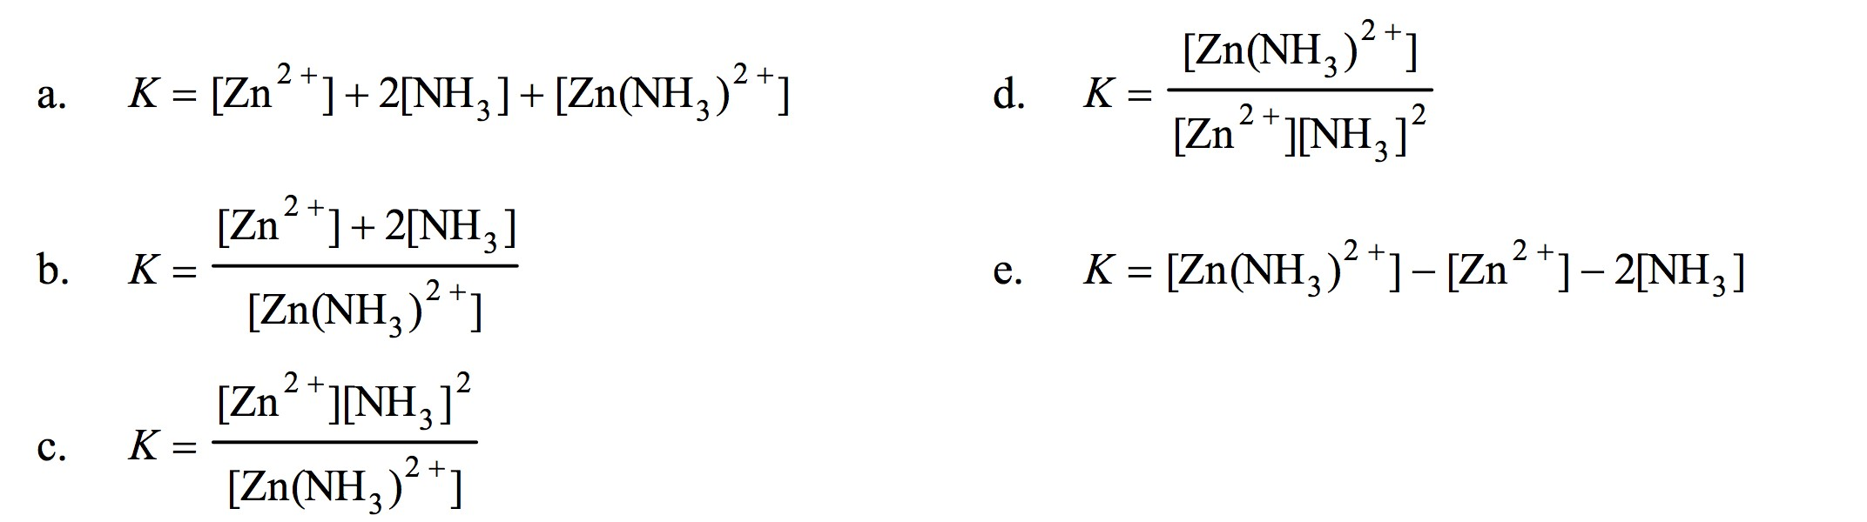
Zn
2+
(
aq
)
+
2

NH
3
(
aq
)

Zn(NH
3
)
2+
(
aq
)

- Write an expression for the equilibrium constant for this reaction.
Ca(OH)₂(s) + 2H⁺(aq) 2H₂O(l) + Ca²⁺(aq)

- Write an expression for the equilibrium constant for this reaction.
NH₄CO₂NH₂(s) 2NH₃(g) + CO₂(g)

- Write an expression for the equilibrium constant for this reaction.
Ti(s) + 2Cl₂(g) TiCl₄ (l)

Dumb and Silly ones! J☺
- Identify the equilibrium expression for the following reaction:
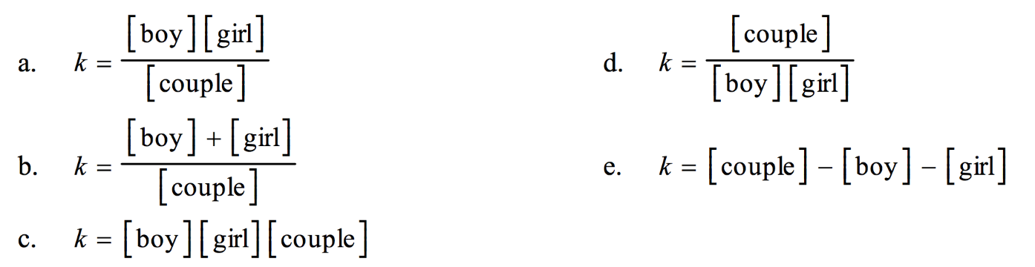
boy + girl
couple

- Write the equilibrium expression for the following reaction, assuming homogeneity:
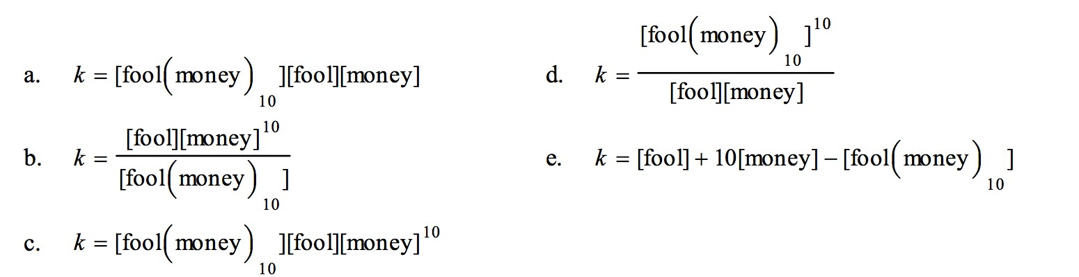
fool(money)
10

fool + 10 money

Manipulations of K: Reversing or Multiplying or Both

- For the chemical equilibrium A + 2B 2C, the value of the equilibrium constant, K, is 10. What is the value of the equilibrium constant for the reaction written in reverse?

2C A + 2B K = ??? Given that: A + 2B 2C K = 10

  - 0.10 d. 100
  - 10 e. –10
  - 1

- The equilibrium constant for the formation of calcium carbonate from the ions in solution is 2.2 × 10⁸ according to the reaction: Ca²⁺(aq) + CO₃^{2–}(aq) CaCO₃(s) K = 2.2 × 10⁸
What is the value of the equilibrium constant for the reverse of this reaction?
CaCO₃(s) Ca²⁺(aq) + CO₃^{2–}(aq) K = ?????

  - the same, 2.2 × 10⁸ d. 4.5 × 10^{–9}
  - –2.2 × 10⁸ e. 4.5 × 10⁹
  - 2.2 × 10^{–8}

- For the chemical equilibrium A + 2B 2C, the value of the equilibrium constant, K, is 10. What is the value of the equilibrium constant for the following reaction?
2A + 4B 4C K = ??? Given that: A + 2B 2C K = 10

  - 0.10 d. 400
  - 0.20 e. 100
  - 40

- For the chemical equilibrium A + 2B 2C, the value of the equilibrium constant, K, is 10. What is the value of the equilibrium constant for the following reaction?

4C 2A + 4B K = ??? Given that: A + 2B 2C K = 10

  - 0.10 d. 20
  - 0.20 e. 100
  - 0.010

- Given: A + B 2C K = 1.2 x 10⁻³.

What is K for the reaction 2C A + B K = ???

K Calculations: Solving for K when all Equilibrium Concentrations are Given

- Calculate K for the following reaction given the following equilibrium concentrations of H₂, CO, and H₂O.

PCl₅(g) PCl₃(g) + Cl₂(g) K = ??

Equilibrium Concentrations (M): .200 .040 .080

- Calculate K for the following reaction given the following equilibrium concentrations of H₂, CO, and H₂O.

C(s) + H₂O(g) CO(g) + H₂(g) K = ??

Equilibrium Concentrations (M): 1.60 .030 .030

- For the following hypothetical equilibrium, what is the value of the equilibrium constant if the concentrations at equilibrium are as shown?
A(g) + 2 B(g) C(g)
Equilibrium Concentrations (M): 4.5 × 10^{–5} 2.2 × 10^{–2} 9.4 × 10^{–3} K = ??

  - 0.22 d. 2.3 × 10⁸
  - 9.9 e. 9.5 × 10³
  - 4.3 × 10⁵

- For the following hypothetical equilibrium, what is the value of the equilibrium constant if the concentrations at equilibrium are as shown?
A(aq) + 2 B(aq) 2C(aq) + D(aq)
4.5 × 10^{–5} 2.2 × 10^{–2} 9.4 × 10^{–3} 1.2 × 10^{–2}

K Calculations: Solving for an Equilibrium Concentration when K and all Other Equilibrium Concentrations are Given

- What is the equilibrium concentration of Br₂ if [HBr] = 0.35 M and [H₂] = 0.22 M at equilibrium?

H₂(g) + Br₂(g) 2HBr(g) K = 62.5

- What is the equilibrium concentration of D?

A(aq) + B(s) 2C(aq) + D(aq) K = 2.0 x 10⁻⁶
4.5 × 10^{–4} 1.2 × 10^{–2} ???????

- What is the equilibrium concentration of C?

A(g) + B(g) 2C(g) + D(g) K = 6.0 x 10⁻⁷
4.5 × 10^{–4} 0.25 ??????? 1.4 × 10^{–3}

Using Ice: Generic, Then Real But Simple Numbers

- In the ICE table started for calculating equilibrium concentrations of the reaction shown, the three terms in the “change” row are __________
M²⁺ + 2L ML₂⁺
[M²⁺] [L] [ML₄⁺]
I 0.20 M 0.40 M 0 M
C ______ ______ ______
E ______ ______ ______
a. –x, –x, +x | d. +x, +2x, +x
b. +x, +x, –x | e. +x, +4x, –x
  - –x, –2x, +x

- In the ICE table started for calculating equilibrium concentrations of the reaction shown, the three terms in the “change” row are __________
M²⁺ + 4L ML₄⁺
[M²⁺] [L] [ML₄⁺]

I 0.10 M 0.32 M 0 M
C ______ ______ ______
E
a. –x, –x, +x | d. +x, +4x, +x
b. +x, +x, –x | e. +x, +4x, –x
  - –x, –4x, +x

- A reaction X + 2Y → 3Z is started with 1.0 M Z and no X or Y. To calculate the equilibrium concentrations of all species using an ICE table, which of the following would you enter in the Z column for the C row?
X(g) + 2Y (g) 3Z(g)
I
C
E

  - 1.0 M d. 1.0 M + 3x
  - 1.0 M – x e. –3x
  - 1.0 M – 3x

- When 4.00 mol of A and 4.00 mol of B are placed in a container and allowed to come to equilibrium, the resulting mixture is found to contain 0.80 mol of D. What are the amounts of A, B, and C at equilibrium?

A(g) + 3B (g) C (g) + D(g)

Initial: 4.00 mol 4.00 mol 0 mol 0.00 mol

Equilibrium: _______ ________ _______ 0.80 mol

Using Ice: Solving for K given Initial Concentrations and at Least one Equilibrium Concentration

- 0.60 mol of Br₂ and 0.60 mol of Cl₂ are placed in a 1.00 L flask and allowed to reach equilibrium. (There is no BrCl at first.) After reaching equilibrium, the flask is found to contain 0.28 mol of BrCl. What is the value of K for this reaction?
Initial:  Equilibrium: |  | Br₂(g) + Cl₂(g) 2 BrCl(g) K=????  0.60 0.60 0  0.28

- When 3.00 mol of A and 4.00 mol of B are placed in a container and allowed to come to equilibrium, the resulting mixture is found to contain 0.80 mol of D. What is the value of K at equilibrium?

A(g) + 2B (g) C (g) + D(g) K=????

Initial: 3.00 mol 4.00 mol 0 mol 0.00 mol

Equilibrium: 0.80 mol

- When 1.00 mol of A and 0.800 mol of B are placed in a 2.00 L container and allowed to come to equilibrium, the resulting mixture is found to be 0.20M in D. What is the value of K at equilibrium? (This problem requires extra step of using quantity and volume to convert to molarity. Here I’m giving you moles; in lab you might instead be starting with grams, and needing to convert grams to moles, then moles to molarity.)

2A(aq) + B (aq) C (g) + D(g) K=????

Initial moles: 1.00 mol 0.80 mol 0 mol 0.00 mol

Initial Molarity (concentration):

Change:

Equilibrium: 0.20 M

Solving for Equilibrium Concentrations Using Ice, Given K

- Concept Question: Given a K value of 0.43 for the following aqueous equilibrium, suppose sample Z is placed into water such that it’s original concentration is 0.033 M. Assume there was zero initial concentration of either A(aq) or B(aq). Once equilibrium has occurred, what will be the equilibrium concentration of Z?
2A(aq) + B(aq) 2Z(aq) K = 0.43

a. more than 0.033 M | c. 0.033 M exactly
b. less than 0.033 M | d. there is no way to tell

- What are the final concentrations of A and A₂ at equilibrium if the initial [A₂] concentration is 0.60M?

A₂ (g) 2A(g) K = 4.2 x 10⁻⁸

Initial: 0.60 0

Equilibrium:

- Find final equilibrium concentrations for HA, H⁺, and A⁻:
HA H⁺ + A⁻ K_{c} = 2.0 x 10⁻⁵
Initial Concentrations 0.60 0 0

- Find final equilibrium concentrations for HA, H⁺, and A⁻:
HA H⁺ + A⁻ K_{c} = 5.0 x 10⁻⁹
Initial Concentrations 0.30 0 0

- Find final equilibrium concentrations for HA, H⁺, and A⁻:
HA H⁺ + A⁻ K_{c} = 0.20
Initial Concentrations 0.30 0 0

- The reaction of bromine gas with chlorine gas, shown here, has a K_{c} value of 7.20 at 200ºC. If a closed vessel was charged with the two reactants, each at an initial concentration of 0.200 M, but with no initial concentration of BrCl, what would be the equilibrium concentration of BrCl(g)?

Br₂(g) + Cl₂(g) 2BrCl(g) K = 7.20
Initial Concentrations 0.20 0.20 0

- Given the initial concentrations shown below, find the equilibrium concentrations for A, B, and C.

A(g) + B(g) 2C(g) K = 9.0 x 10⁻⁸
Initial Concentrations 0.500M 0.500M 0.000M

LeChatelier’s Principle: When a System at Equilibrium has something happen that disrupts the equilibrium. How will the concentrations respond to reestablish equilibrium?
• 3 Types of disruptions:
      - Change in Concentration
      - Change in Temperature
      - Change in Volume or Pressure
Concepts involving Q
  - When a System may not Actually be at Equilibrium to Start with
  - Or after a LeChatelier’s Principle Disruption

- Which of the following occurs when reactants are added to a chemical reaction in solution or the gas phase at equilibrium?
  - Q increases, so the equilibrium shifts to produce more products.
  - Q increases, so the equilibrium shifts to produce more reactants.
  - Q decreases, so the equilibrium shifts to produce more products.
  - Q decreases, so the equilibrium shifts to produce more reactants.
  - Q is unchanged by the addition of reactants.

- Which of the following occurs when products are added to a chemical reaction in solution or the gas phase at equilibrium?
  - Q increases, so the equilibrium shifts to produce more products.
  - Q increases, so the equilibrium shifts to produce more reactants.
  - Q decreases, so the equilibrium shifts to produce more products.
  - Q decreases, so the equilibrium shifts to produce more reactants.

- Which of the following occurs when products are removed from a chemical reaction in solution or the gas phase at equilibrium?
  - Q increases, so the equilibrium shifts to produce more products.
  - Q increases, so the equilibrium shifts to produce more reactants.
  - Q decreases, so the equilibrium shifts to produce more products.
  - Q decreases, so the equilibrium shifts to produce more reactants.

- Which of the following occurs when reactants are removed from a chemical reaction in solution or the gas phase at equilibrium?
  - Q increases, so the equilibrium shifts to produce more products.
  - Q increases, so the equilibrium shifts to produce more reactants.
  - Q decreases, so the equilibrium shifts to produce more products.
  - Q decreases, so the equilibrium shifts to produce more reactants.

- Increasing the temperature of an exothermic reaction results in __________
  - more products and fewer reactants.
  - more reactants and fewer products.
  - more reactants and products.
  - fewer reactants and products.
  - no change in the quantities of reactants and products.

- Increasing the temperature of an endothermic reaction results in __________
  - more products and fewer reactants.
  - more reactants and fewer products.
  - more reactants and products.
  - fewer reactants and products.
  - no change in the quantities of reactants and products.

- For the following reaction, write how the each of the changes will affect the indicated quantity, assuming a container of fixed size. Write “increase”, “decrease”, or “no change”. (Or use an “up” arrow to indicate “increase”, and a “down” arrow to indicate “decrease”.) (For a chemical added, write how it would respond AFTER the addition.)
H₂(g) + Br₂(g) 2HBr(g) ΔHº = -103.7kJ

Change | [H₂] | [Br₂] | [HBr] | K value
1. Some H₂ added
2. Some HBr added
3. Some H₂ removed
4. Some HBr removed
5. The temperature is increased
6. The temperature is decreased
7. Pressure is increased and the container volume decreased

- For the following reaction, write how the each of the changes will affect the indicated quantity, assuming a container of fixed size. Write “increase”, “decrease”, or “no change”. (Or use an “up” arrow to indicate “increase”, and a “down” arrow to indicate “decrease”.) (For a chemical added, write how it would respond AFTER the addition.)
NO₂(g) 2NO(g) + O₂ (g) ΔHº = +62kJ

Change | [NO₂] | [NO ] | [O₂] | K value
1. Some NO₂ added
2. Some O₂ added
3. Some NO₂ removed
4. Some O₂ removed
5. The temperature is increased
6. The temperature is decreased
7. Pressure is increased (and the container volume decreased)
8. Pressure is decreased (so the container volume increases)

- Given: 2A(g) B(g) + C(g) ∆H˚ = +27 kJ K = 3.2 x 10⁻⁴

Which of the following would be true if the temperature were increased from 25˚C to 100˚C?
      - The value of K would be smaller.
      - The concentration of A(g) would be increased.
      - The concentration of B(g) would increase.

    - 1 only
    - 2 only
    - 3 only
    - 1 and 2 only
    - 2 and 3 only

- Which of the listed perturbations will change the position of equilibrium for the following reaction? List those that do as a sequence of letters, e.g., ACE. (There is more than one.)
NH₄CO₂NH₂(s) 2NH₃(g) + CO₂(g)
    - Increasing the quantity of NH₄CO₂NH₂(s)
    - Removing CO₂(g)
    - Increasing the total pressure
    - Increasing the volume of the container

- Given the following reaction at equilibrium, which of the following alterations will increase the amount (in moles) of SO₂Cl₂: (there is only one correct answer)

SO₂(g) + Cl₂(g) SO₂Cl₂(g) ∆H˚ = -67 kJ

  - adding heat to the system
  - adding Cl₂ to the system.
  - removing Cl₂ from the system.
  - increasing the volume of the reaction vessel.

- Given: A(s) + B(l) C(g) + D(g) ∆H˚ = 84.3 kJ

If the above reactants and products are contained in a closed vessel and the reaction system is at equilibrium, the number of moles of C can be decreased by which of the following? (Note that the reactants are solid and liquid.)

  - adding some A to the system.
  - removing some D from the system.
  - decreasing the size/volume of the reaction vessel.
  - increasing the temperature of the reaction system.
  - adding some B to the system.

- Calcium hydroxide and lead chloride both have limited solubility in neutral water. When acid is added, the solubility of calcium hydroxide goes way up, but that of lead chloride doesn’t change. Which statement explains the acid impact?

Ca(OH)₂(s) Ca²⁺(aq) + 2 HO⁻(aq) K=4.7 x 10⁻⁶
PbCl₂(s) Pb²⁺(aq) + 2 Cl⁻(aq) K=1.6 x 10⁻⁵
HO⁻(aq) + H⁺(aq) à→ H₂O (l)

  - Acid reacts with the calcium ions that are produced.
  - Acid increases the solubility of any slightly-soluble solid.
  - Acid reacts with the hydroxide that is produced from calcium hydroxide. By removing the hydroxide product, this has a LeChatelier-type impact and results in more calcium hydroxide dissolving to produce more calcium ions.

- PbCl₂ has limited solubility in neutral water. But the amount of lead ions is reduced when sodium chloride is added to the water. Addition of sodium chloride has no impact on the solubility of Ca(OH)_{2.} Which statement explains why?

PbCl₂(s) Pb²⁺(aq) + 2 Cl⁻(aq) K=1.6 x 10⁻⁵

  - Sodium ions reacts with the lead ions that are produced.
  - Addition of sodium ions reduces the solubility of any slightly-soluble solid.
c. Adding sodium chloride effectively adds aqueous chloride ions. The addition of chloride ions has a Le Chatelier
type impact, drives the PbCl₂ solubility to the left, and results in less PbCl₂ dissolving.

