The Bohr Model of the Atom
History
Democritus
Dalton
Thomson
Rutherford
Meanwhile, in physics…….
Scientists were studying light and all of its properties. They were really studying
______________________________________________________ - which is any form of energy
that travels in a _______________________. They had learned everything about this energy and its wave properties – or so they thought! 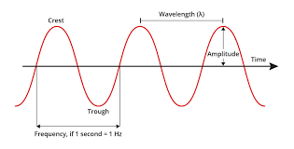.
Properties of waves:
Wavelength - __________________________________________________________________
Frequency - ___________________________________________________________________
Speed (velocity) – All electromagnetic radiation travels at the same speed in a vacuum. We call this speed the speed of light (c). The speed of light is a constant in nature. It is 3.00 x 10⁸ m/s.
Wavelength, frequency and energy of the waves are mathematically related:
c = E = h

Different types of Electromagnetic Radiation:
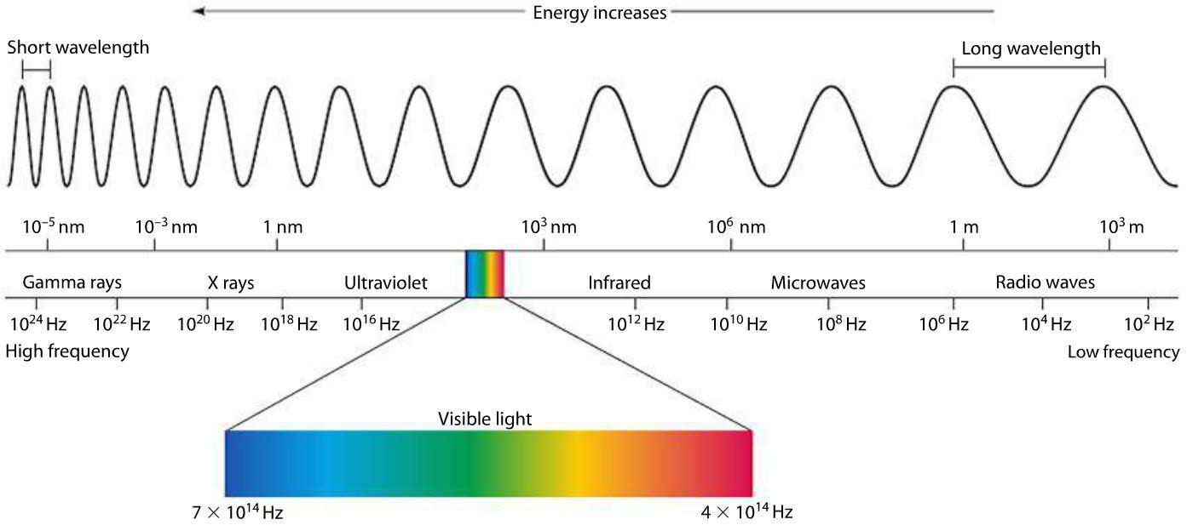
Radical Martians Invaded Venus Using X-ray Guns
Radio Microwaves Infrared Visible Ultraviolet X-rays Gamma
R O Y G B I V
Low Energy ------------------------------------------------ High Energy

Then, along comes Einstein. He discovers a phenomenon called the photoelectric effect. He won a Nobel Prize for this discovery and it changed the way we think about electrons.
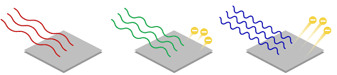
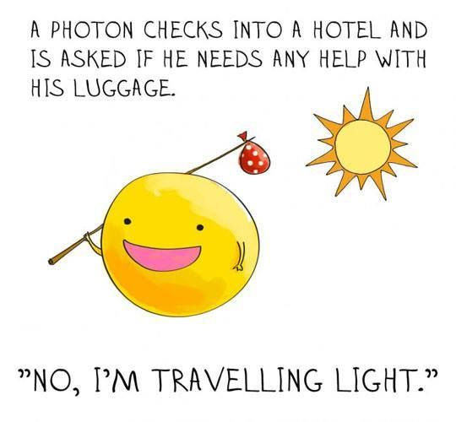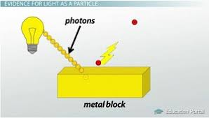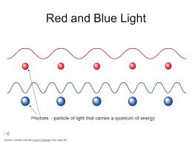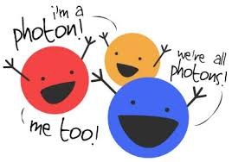
Einstein proved that waves of electromagnetic radiation had particle properties. One of these “particles” of light was called a
PHOTON

Each photon contains a QUANTUM of energy.

Now around this same time, chemists were trying to figure out how the electrons were arranged around the nucleus. A Danish scientist named Neils Bohr did an experiment with light and hydrogen gas and proposed that electrons were arranged around the nucleus in layers which he called energy levels. He determined that there are 7 of these layers of electrons.
Bohr’s Experiment
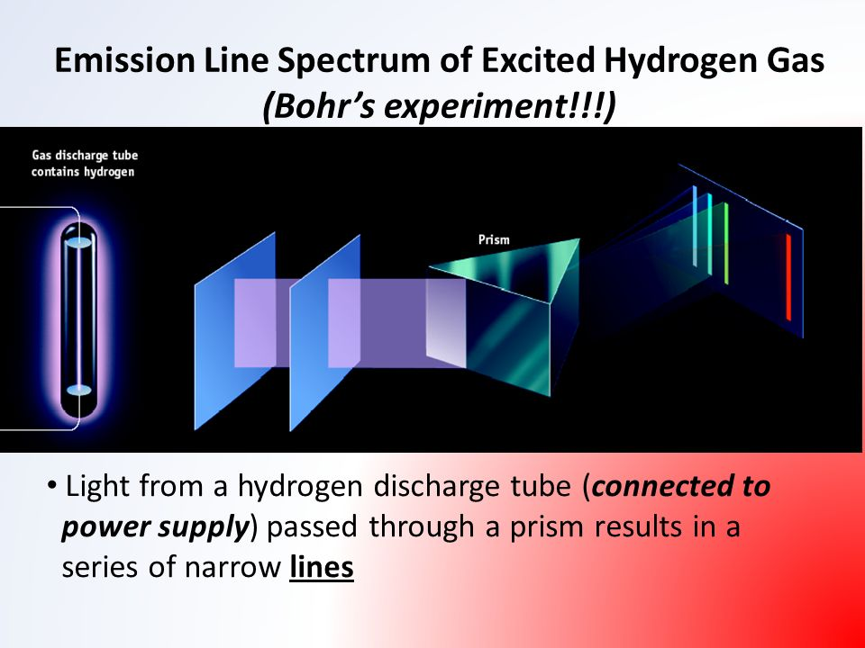

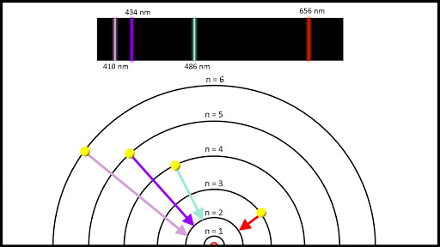

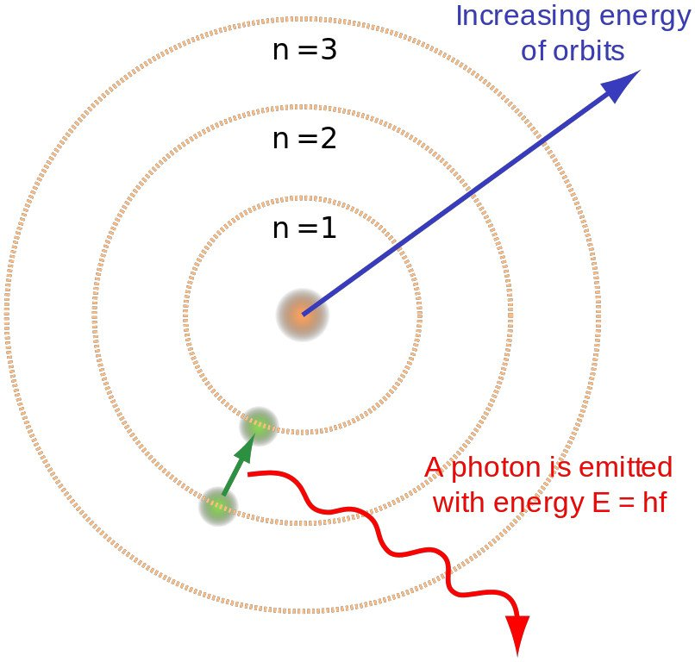

- Electrons absorb energy in the form of _____________, ______________, or ___________________. This causes the electron to jump farther away from the nucleus (to a _________________ energy level). When the electron is in this higher energy, we say that the electron is ______________________ or in an excited state.
- Electrons will not remain in the excited state. They immediately lose the energy they absorbed and return to their original position closer to the nucleus and lower in energy. The low energy position is called the _________________________________.
- When the electrons release energy, it is always released in the form of LIGHT! We see this as different colors. The different colors are different wavelengths and different energies! This is what gave Bohr the idea that electrons existed in different energy levels. They was NO EVIDENCE that electrons were ever in-between energy levels! This is the significance of the BRIGHT LINE SPECTRUM.

