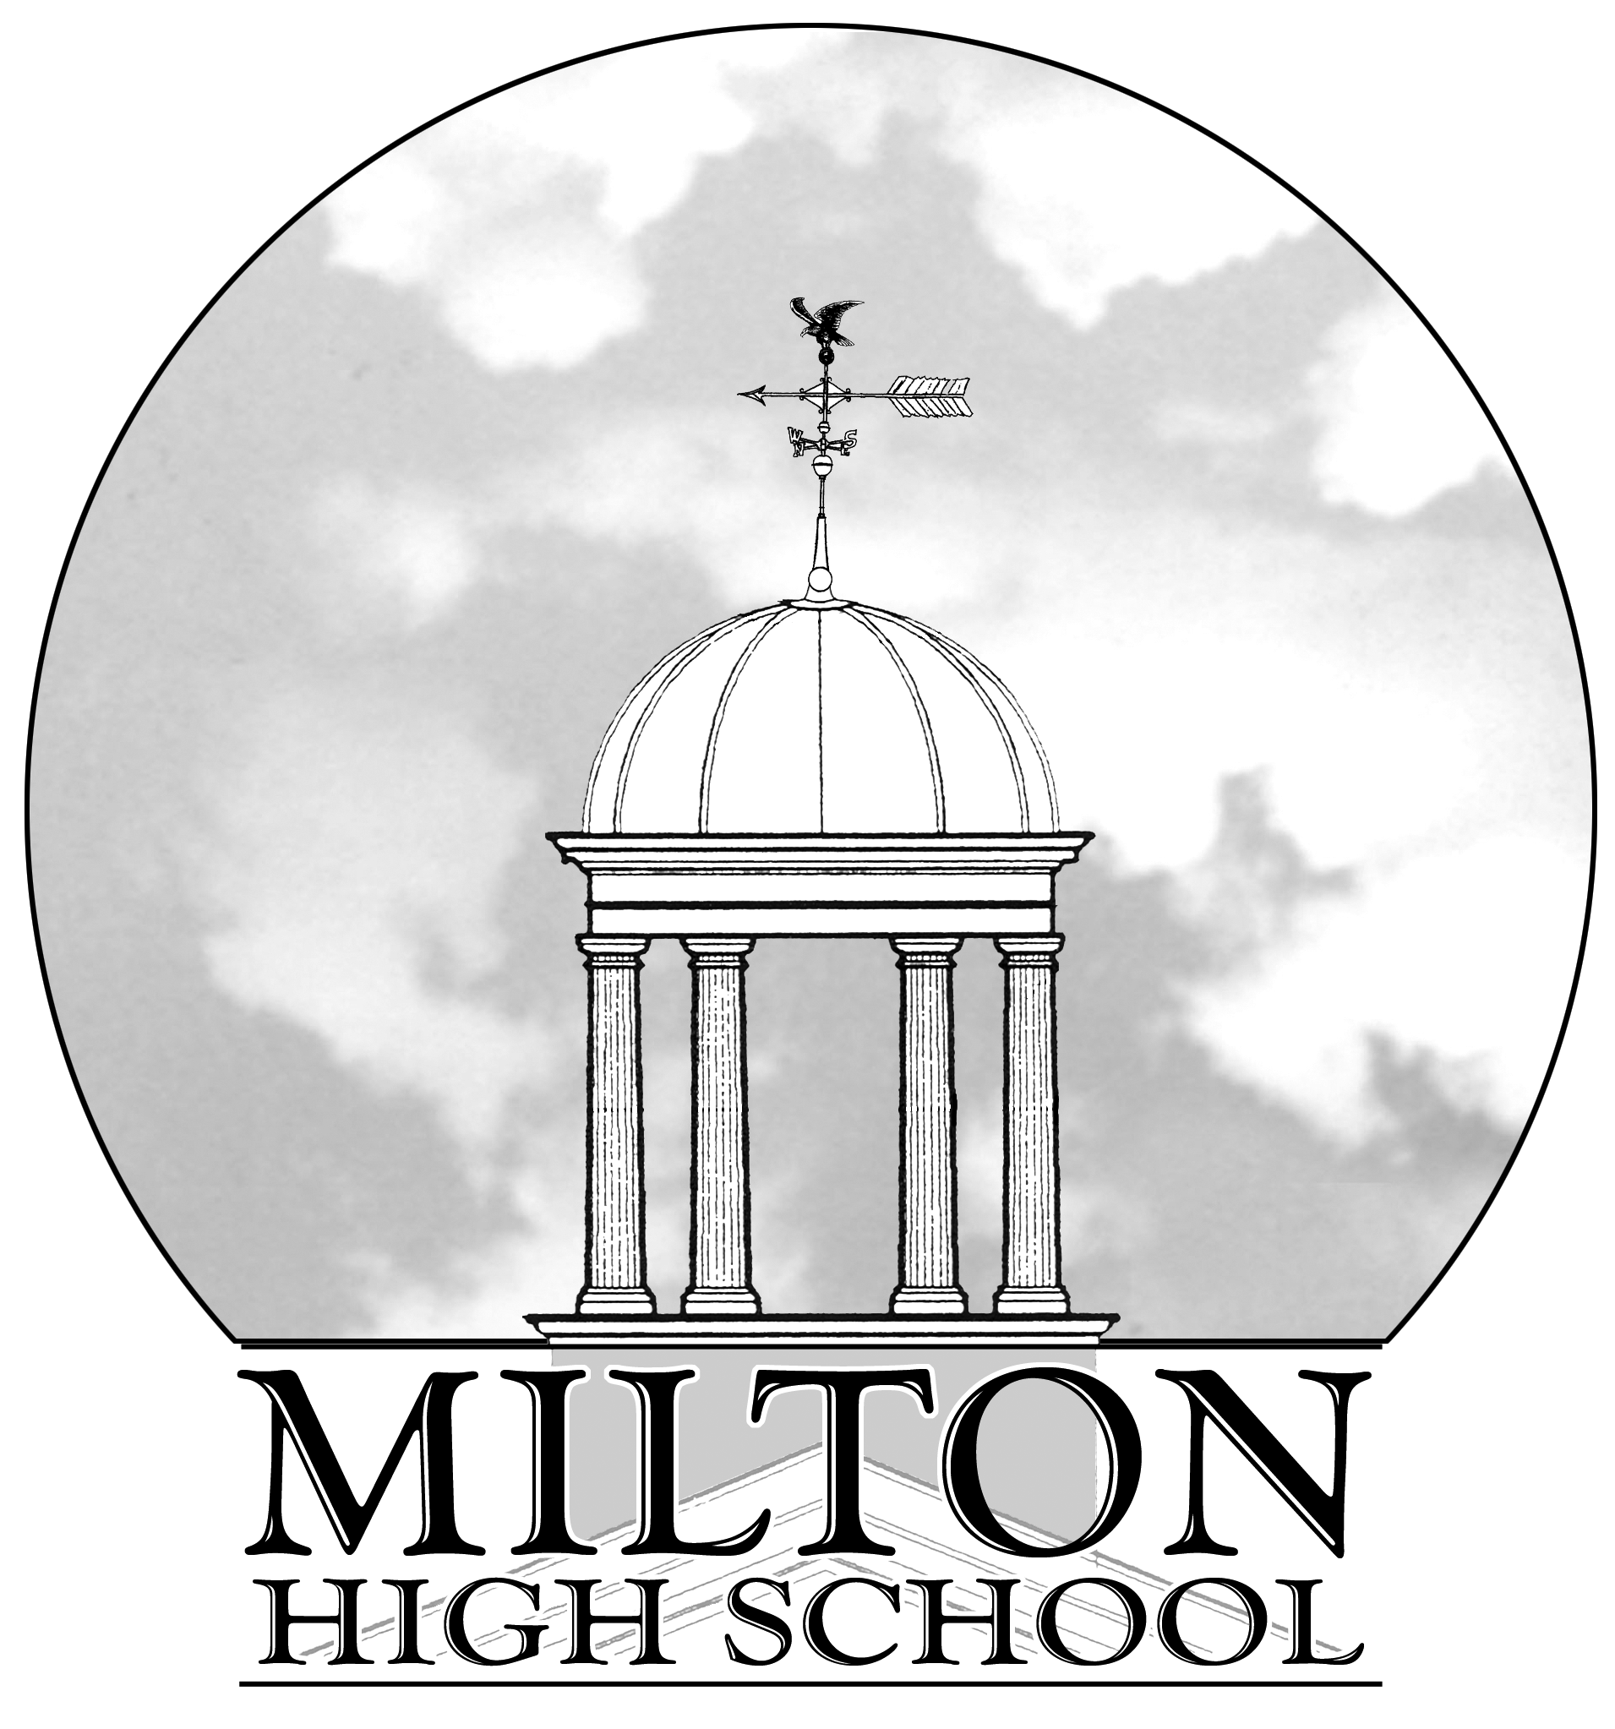
AP CHEMISTRY – SECOND SEMESTER 2020-2021
Karol Higgins - Room 1333
Email: higginsk@fultonschools.org
Class Web Site: http://www.higginschemistry.weebly.com

Course Description
The AP Chemistry course is designed to be the equivalent of the general chemistry course taken during the freshman year of college. Students will receive a solid, first-year college experience, both conceptually and in the laboratory. The labs serve to supplement the learning in the lecture portion of the class. As this is a second year class, the following topics are covered rapidly: molar relationships, electronic structure, periodicity, history of atomic theory, intra- and intermolecular bonding, molecular geometry, gas laws, and solutions. This allows adequate time for the in-depth study of more complex topics: chemical kinetics, equilibrium, thermodynamics, redox reactions, materials science, buffer systems, and coordination complexes. Nuclear chemistry and organic chemistry topics will be included in each unit as appropriate.

Class/Student Expectations
AP Chemistry students are expected to be actively engaged in the learning process through classroom discussion, laboratory inquiries, scientific research and personal initiative. Students will develop their abilities to think clearly and to express their ideas, orally and in writing, with clarity and logic. Students will attain a depth of understanding of fundamental chemical principles and a reasonable competence in dealing with chemical problems.

During remote learning, students are expected to actively participate in all synchronous learning activities with their video function ON. Only students that have video on will be allowed to take a test or quiz. Students that do not have video capability should contact the school to get a device with video capability.

Students are expected to complete all asynchronous activities and assignments – even if not for a grade. Students are expected to utilize teacher office hours if extra help is needed.

While every student is different, the College Board recommends that AP chemistry students spend one hour outside of class for every hour in class in individual study and practice. Please know that this statement is based on 5 hours of in-class instruction per week.

Textbook Information
- You can access the etext and other class resources at: https://www.pearson.com/mastering
- Title: Chemistry: The Central Science AP Edition, (Brown, LeMay, et al., 2018), 14E
- Publisher: Pearson
- ISBN: 9780134617251
- Price: $173.47

Units of Study

Unit | Topic and Chapters | Time
5 | Kinetics (Chapter 14) – Reaction Mechanisms and Reaction Profiles only  Thermochemistry (Chapter 5)  Thermodynamics (Chapter 19) | 3
6 | Chemical Equiibrium (Chapters 15 and 17) | 3
7 | Acids and Bases (Chapter 16 and 17) | 4
8 | Solutions (Chapter 13)  Electrochemistry (Chapter 20) | 2 ½
 | Review for Final Exam/AP Chemistry Exam | 2 ½

Grades
Student grades will be calculated based on the completion of nine summative assignments/assessments and a final exam. Summative assessments are 85% of the class average and the final exam is 15%. The table below shows the weights of the summative assessments.
Grade | Type | Weight
1 | Unit 1 Quiz | 1
2 | Unit 1 Test | 2
3 | Unit 2 Quiz | 1
4 | Unit 2 Test | 2
5 | Unit 3 Quiz | 1
6 | Unit 3 Test | 2
7 | Unit 4 Quiz | 1
8 | Unit 4 Test | 2
9 | Lab Average | 1

Students will be required to complete all nine summative assignments/assessments AND be passing the class to exempt the final exam.

There is no extra credit in this class and your lowest test grade is not dropped or replaced at the end of this semester. It is therefore very important that you do all the assigned work and obtain extra help when needed. You should prepare to the best of your ability for every assessment.
Grade Recovery
If a student receives an incomplete or a failing grade (below 79%) on any of the summative assignments/assessments, the student will have one attempt to redo/retake an assessment over the material. Eligibility for a redo/retake is for students who receive below a 79. The highest grade that can be earned on the redo/retake is a 79. Students must complete the recovery assignment before the next summative assessment is given or before the end of the marking period if there is not another summative assessment given.

Attendance
Students will be marked present for daily course attendance if the student performs one of the following actions: participates in the synchronous lesson or is logged into the class and has direct contact with the teacher or submits an assignment in the Teams platform. If a student cannot attend “live” due to connectivity or technology issues, the student should reach out through Teams to log into the class, get information or view what was missed, and contact the teacher to alert of presence. Due to Infinite Campus attendance settings, if this happens, the teacher and/or attendance office will correct the student’s attendance within 48 hours. It is the student’s responsibility to reach out to the teacher to correct attendance before the end of the day.

Honor Code
URL provides unique challenges to teachers and students with regards to the Honor Code. However, cheating and plagiarism will not be tolerated. Cheating is defined as “the giving or receiving, in any form, information relating to a gradable experience.” Cheating is any act whose intent is to gain reward or success that is not honestly earned. Plagiarism is the presentation of materials as ones’ own effort when it is actually the work of another. Violations of the Honor Code will result in a referral to the proper administrator for disciplinary action pursuant to Rule 9 in the FCS Student Code of Conduct and Discipline Handbook.

Communication
Students: Every student should check their FCS email EVERYDAY for announcements and communication. Teachers will communicate with students via Teams and FCS email.
Parents: Teachers will call and/or email and/or Teams meet with parents and their student, as needed, to discuss student progress.

Help Hours
Extra help can be obtained on Monday and Wednesday afternoons from 3:30-4:00 pm. I will end the AP Chemistry Help Session Team at 4:00 if no students join. Extra help can be obtained other times if you will give me advanced notice.

Some tips for success:

- Be present and on time every day.
- Do not wait to ask questions if confused.
- Do not hesitate to ask for extra help.
- Form a study group or have a study partner. (It is nice to have a fellow student you can call when you have a question.)
- Attempt homework problems before checking answers.
- Remove all distractions when studying or doing homework.
- Attempt all homework by yourself. You cannot learn to solve problems effectively by copying them.

“That which we persist in doing becomes easier to do, not that the nature of the thing has changed but that our power to do has increased.”
Ralph Waldo Emerson

- Outline text material and pause to study sample problems, pictures and graphs.
- Be careful with significant figures and units for an answer. Very few numerical answers will be given that do not have units.
- Do whatever it takes to pay attention in class. The first time a topic is discussed is the best time to attain clarity. Please pay attention because I can explain it to you, but I can’t understand it for you!
- Review questions missed on all assignments/quizzes/tests.
- KEEP SMILING!

